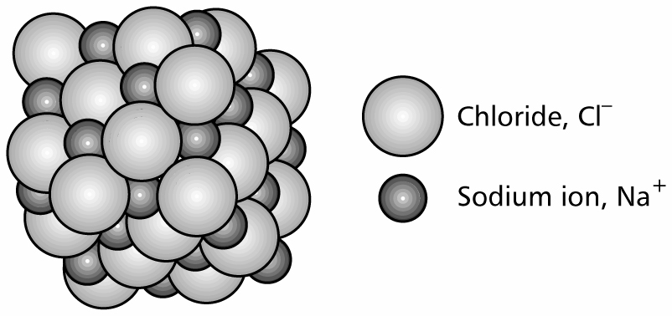

Ionic Bonding

NAME …………………………………………………………………….

IONIC BONDING Name______________________

Electrons are arranged in energy levels or shells: (2,8,8)
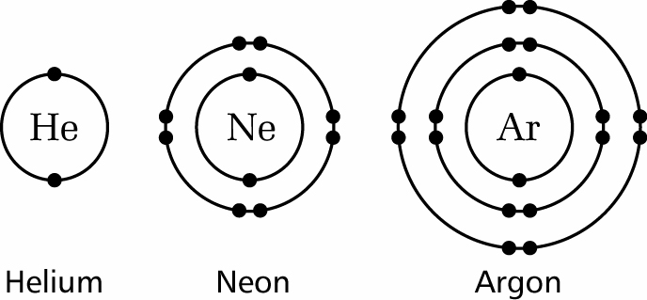

Noble gases are chemically stable because they have 8 electrons in their outer shell (except helium – only 2 electrons needed to fill the first shell)

s-block elements (Group 1 and 2) lose one or more electrons to form stable cations (positively charged ions)

p-block elements (Group 5, 6 and 7) gain one or more electrons to form stable anions (negatively charged ions)
The s-block element sodium (2,8,1) has 1 electron more than a stable noble gas structure (2,8). If it gave away that electron it would become more stable.
The p-block element chlorine (2,8,7) has 1 electron short of a stable noble gas structure (2,8,8). If it could gain an electron from somewhere it too would become more stable.
The answer is obvious. If a sodium atom gives an electron to a chlorine atom, both become more stable.

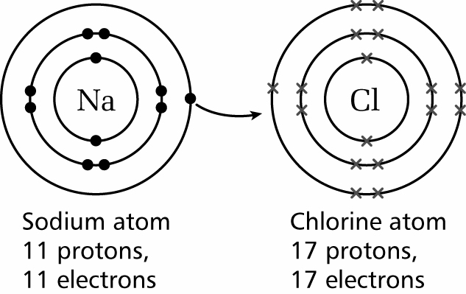

Sodium has lost an electron, so it no longer has equal numbers of electrons and protons. Because it has one more proton than electron, it has a charge of 1+.
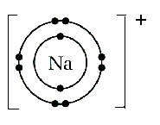
Sodium ion
11 protons
10 electrons
The chlorine has gained an electron, so it now has one more electron than proton. It therefore has a charge of 1-.
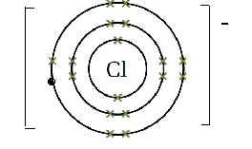
Chloride ion
17 protons
18 electrons
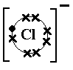
“Dot-and-cross” diagram for the formation of sodium chloride
We only show outer electrons
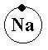

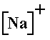

Electrons are transferred from one atom to the other resulting in the formation of positive and negative ions.
These changes can be represented using half-equations:
Sodium atoms lose one electron: Na → Na⁺ + e⁻
Both chlorine atoms in a chlorine molecule gain one electron: Cl₂ + 2e⁻ → 2Cl⁻
This results in the formation of an ionic compound: Na⁺Cl⁻
The electrostatic attractions between the positive and negative ions hold the compound together.
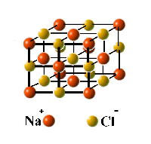
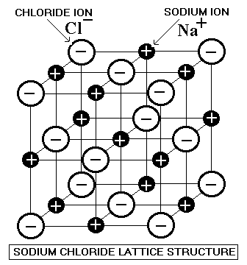
Millions of anions and cations pack together in a giant ionic lattice

Learn this definition
Definition: An ionic bond is the electrostatic force of attraction between the positive and negative ions in a giant ionic lattice.

Draw a diagram to represent the structure
of sodium chloride.
- Sodium Cation

- Chloride anion

How many nearest neighbours has:

(i) Each chloride ion? - 6

(ii) Each sodium ion? - 6

Exercise 1

Write the electronic configurations for atoms of:
(a) Magnesium, Mg (2, 8, 2)

(b) Oxygen, O (2, 6)

(c) Given that atoms lose or gain electrons to achieve a noble gas electron configuration, give the symbols for the ions formed by Mg and O – Mg²⁺, O²⁻

(d) Draw a Lewis diagram for the formation of magnesium oxide, showing how many electrons are transferred.

- Two electrons are transferred from magnesium to oxygen

Mg²⁺
O²⁻

(e) Magnesium oxide has an extremely high melting point which makes it suitable as a lining for furnaces.

(i) Explain, in terms of structure and bonding, why magnesium oxide has this property.

Magnesium oxide has an extremely high melting point because of the strong
electrostatic forces between the magnesium and oxide ions present in the
very rigid lattice.

(ii) Draw a diagram to show the structure of the crystal lattice.

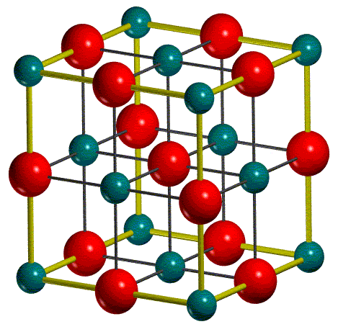

Exercise 2
Show outer shells only

Draw Lewis diagrams for: (SEE PAPER COPY)

  - Potassium oxide

  - Calcium chloride

  - Caesium Bromide

  - Sodium hydroxide

  - Calcium carbonate

Exercise 3

Complete the table.
Property of ionic compound | Explanation
High melting point | The strong electrostatic forces of attraction between oppositely charged ions holds the lattice together very strongly making it difficult to break apart. Thus, the compound has a very high melting point.
Conducts electricity only when molten or in solution | When an ionic compound is molten or in solution its ions are free to move in the solution meaning that it can now conduct electricity.
Hard but brittle | Ionic compounds are formed in networks. When force is applied to the network, the layers shift alignment but stay together due to the strength of the electrostatic forces between oppositely charged ions. This results in the brittle nature of ionic compounds.

Answer the following questions:

a) Why does magnesium oxide have a higher melting point than sodium chloride?

Magnesium and oxide ions have a greater charge of 2+/2- and therefore have stronger forces of electrostatic attraction between the ions in a lattice compared to sodium and chloride which have charges of 1+/1- respectively.

b) What happens when an ionic compound dissolves in water?

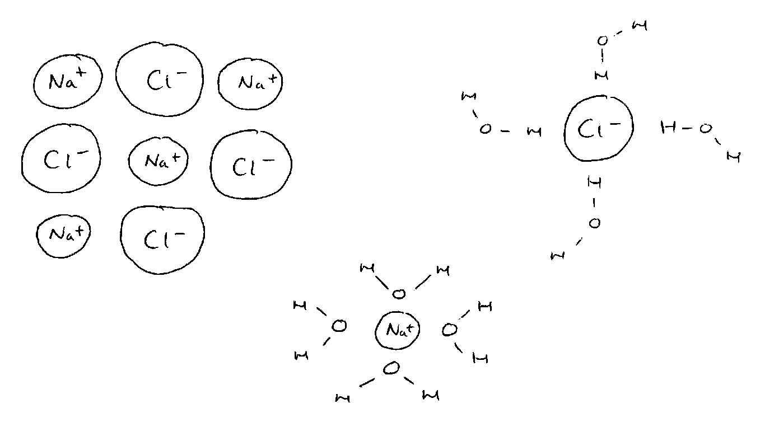
The ions separate and evenly distribute in the
water becoming an aqueous substance. This
is known as disassociation and is due to the water
reducing the strong electrostatic forces of attraction
between ions.

c) Why are some ionic compounds insoluble in water?

The ionic forces are so high they are not broken down by water and the compounds’ structure remains intact.

d) Ionic compounds only conduct electricity when melted or dissolved in water.

This is a test for an ionic compound.

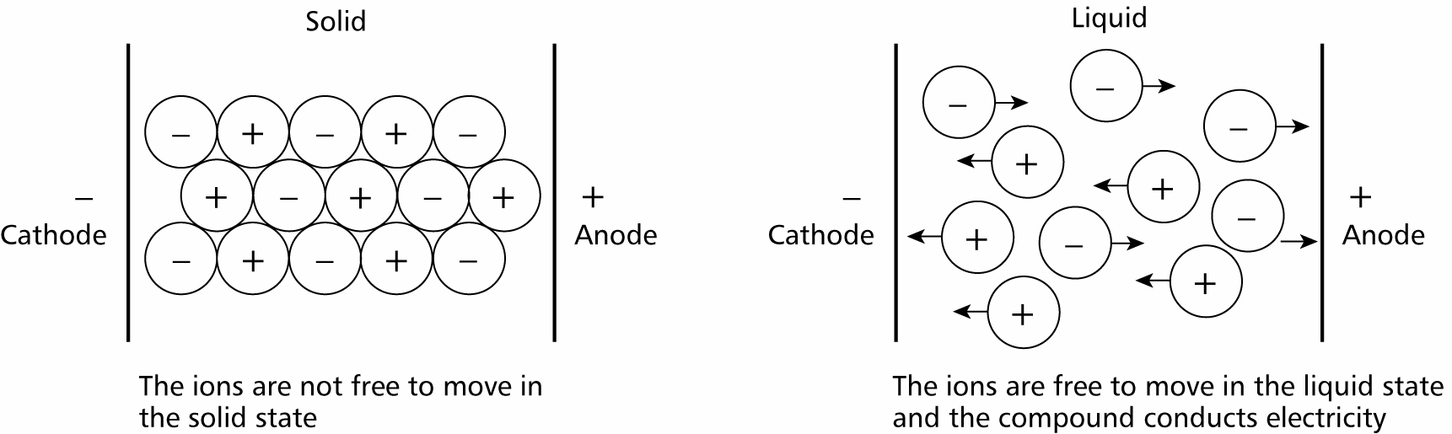

SOLUBILITY RULES

Nitrates are soluble

Sulphates are soluble except lead and barium sulphate

Chlorides are soluble except silver and lead chloride
Bromides bromide
Iodides iodide

Hydroxides are insoluble except sodium and potassium hydroxide

Carbonates are insoluble except sodium and potassium carbonate

WRITING EQUATIONS FOR PRECIPITATION REACTIONS

OBSERVATION: Iron(II) chloride solution reacts with sodium hydroxide solution to form a green precipitate

WORD EQUATION: iron(II) chloride + sodium hydroxide → iron(II) hydroxide + sodium chloride

SYMBOL EQUATION: FeCl_{2(aq)} + 2NaOH_{(aq)} → Fe(OH)_{2(s)} + 2NaCl_{(aq)}

IONIC EQUATION: Fe²⁺_{(aq)} + 2OH⁻_{(aq)} → Fe(OH)_{2(s)}

OBSERVATION: Calcium bromide solution reacts with sodium hydroxide solution to form a white precipitate

WORD EQUATION: calcium bromide + sodium hydroxide → calcium hydroxide + sodium bromide

SYMBOL EQUATION: CaBr_{2 (aq)} + 2NaOH _{(aq)} → Ca(OH)_{2 (s)} + 2NaBr _{(aq)}

IONIC EQUATION: Ca _{(aq)} + Br₂ _{(aq)} + 2Na _{(aq)} + 2OH _{(aq)} → Ca(OH)_{2 (s)} + 2Na _{(aq)} + 2Br _{(aq)}

OBSERVATION: Iron(II) chloride solution reacts with silver nitrate solution to form a white precipitate

WORD EQUATION: iron(II) chloride + silver nitrate → silver chloride + iron nitrate
A salt is an ionic compound containing a positive ion (cation) and a negative ion (anion).
SYMBOL EQUATION: FeCl_{2(aq)} + 2AgNO_{3(aq)} → 2AgCl_{(s)} + Fe(NO₃)_{2(aq)}

IONIC EQUATION: Ag⁺_{(aq)} + Cl⁻_{(aq)} → AgCl_{(s)}

OBSERVATION: Calcium bromide solution reacts with silver nitrate solution to form a cream precipitate

WORD EQUATION: calcium bromide + silver nitrate → calcium nitrate + silver bromide

SYMBOL EQUATION: CaBr_{2 (aq)} + AgNO_{3 (aq)} → CaNO_{3 (aq)} + AgBr_{2 (s)}

IONIC EQUATION: Ca _{(aq)} + Br₂ _{(aq)} + Ag _{(aq)} + NO₃ _{(aq)} → Ca _{(aq)} + NO₃ _{(aq)} + AgBr_{2 (s)}

QUESTIONS

1 (a) State what is meant by an ionic bond.

An ionic bond is when metals and non-metals become ions and bond together in a lattice to achieve the stability of the nearest noble gas.
(1 mark)

(b) Draw a ‘dot-and-cross’ diagram to show the bonding in magnesium oxide.
You should show outer electron shells only.

[Mg]²⁺ [:O:]²⁻

    - Imagine dots all around O
(2 marks)

(c) Magnesium oxide has an extremely high melting point which makes it suitable as a lining for furnaces.

Explain, in terms of its structure and bonding, why magnesium oxide has this property.

Magnesium oxide is an ionic compound. This means it bonds together in a lattice and has very strong electrostatic forces of attraction between ions. The strength of the lattice
Means that magnesium oxide has an extremely high melting point as it becomes very
Hard to break the bonds between ions.
(3 marks)

TOTAL 6 MARKS

2 The question refers to calcium chloride, made up of Ca²⁺ and Cl⁻ ions.

(a) Complete the table below.

species | number of
species | protons | electrons
Ca²⁺ | 20 | 18
Cl⁻ | 17 | 18
(2 marks)

(b) (i) What is the formula of calcium chloride?

CaCl₂

(1 mark)

(ii) Using outer electron shells only, draw a ‘dot-and-cross’ diagram of calcium chloride.

[Cl.]⁻[Ca]²⁺[.Cl]⁻
(2 marks)

TOTAL 5 MARKS

3 Element A is in Group 5 of the Periodic Table.
Each atom of element A has 15 electrons.

(a) Identify element A. - Phosphorus
(1 mark)

(b) Write the electronic configuration of an atom of element A. – (2, 8, 5)
(1 mark)

(c) Predict the charge on an ion of element A and write its electronic configuration.

(i) Charge on ion of A. – P³⁻

(ii) Electronic configuration of ion of A. – (2, 8, 8)

(2 marks)

TOTAL 4 MARKS

4 Magnesium fluoride, MgF₂, has ionic bonding.

- How does ionic bonding hold particles in MgF₂ together?

The electrostatic attraction between positive magnesium and negative fluorine ions holds the ionic lattice together.
(2 marks)

(b) Draw a ‘dot-and-cross’ diagram for magnesium fluoride, MgF₂.
Show outer electron shells only.

[F.]⁻[Mg]²⁺[.F]⁻
(2 marks)

(c) Magnesium fluoride is produced when magnesium reacts with fluorine.

Complete the half-equations below to show the formation of the ions in magnesium fluoride in this reaction.

Mg → Mg²⁺ + 2e⁻

F₂ + 2e⁻ → 2F²⁻
(2 marks)

(d) A student found that magnesium fluoride has different electrical conductivities when solid and when dissolved in water.
Explain these two observations.

When magnesium fluoride is in a solid form, it is a network. The ions do not move and
Are strongly held together by the electrostatic forces between oppositely charged ions.
When magnesium fluoride is dissolved in water, the ions disassociate and are free to
move within the solution, evenly distributing themselves. This means that electricity is
free to move within the solution as the ions are unrestricted.

(2 marks)

TOTAL 8 MARKS

5 Sodium reacts with chlorine to form sodium chloride, NaCl.

- Describe the bonding in sodium chloride.

Sodium chloride is an ionic compound. Sodium is a metal and chloride is a non-metal. They bond together and become ions to gain the stability of the nearest noble gas. The create a network of positively and negatively charged ions. The electrostatic forces of attraction between oppositely charged ions hold the network together.
(3 marks)

(b) Relate the physical properties of sodium chloride to its structure and bonding.
You should use diagrams to illustrate your answers.

Sodium chloride cannot conduct electricity, is brittle and has a very high melting and boiling point. This is because sodium chloride is an ionic compound which bonds together in a network. Because of the rigid structure of a sodium chloride network, electricity is unable to move throughout the compound and thus the compound cannot conduct electricity. The compound is brittle because of it being a network. Layers of the network can be moved, re-aligning the ions. However, the ions remain together because of the strong electrostatic forces between oppositely charged ions. Due to the strength of the electrostatic forces, sodium chloride has a high melting and boiling point.
(3 marks)

[TOTAL 6 MARKS]

